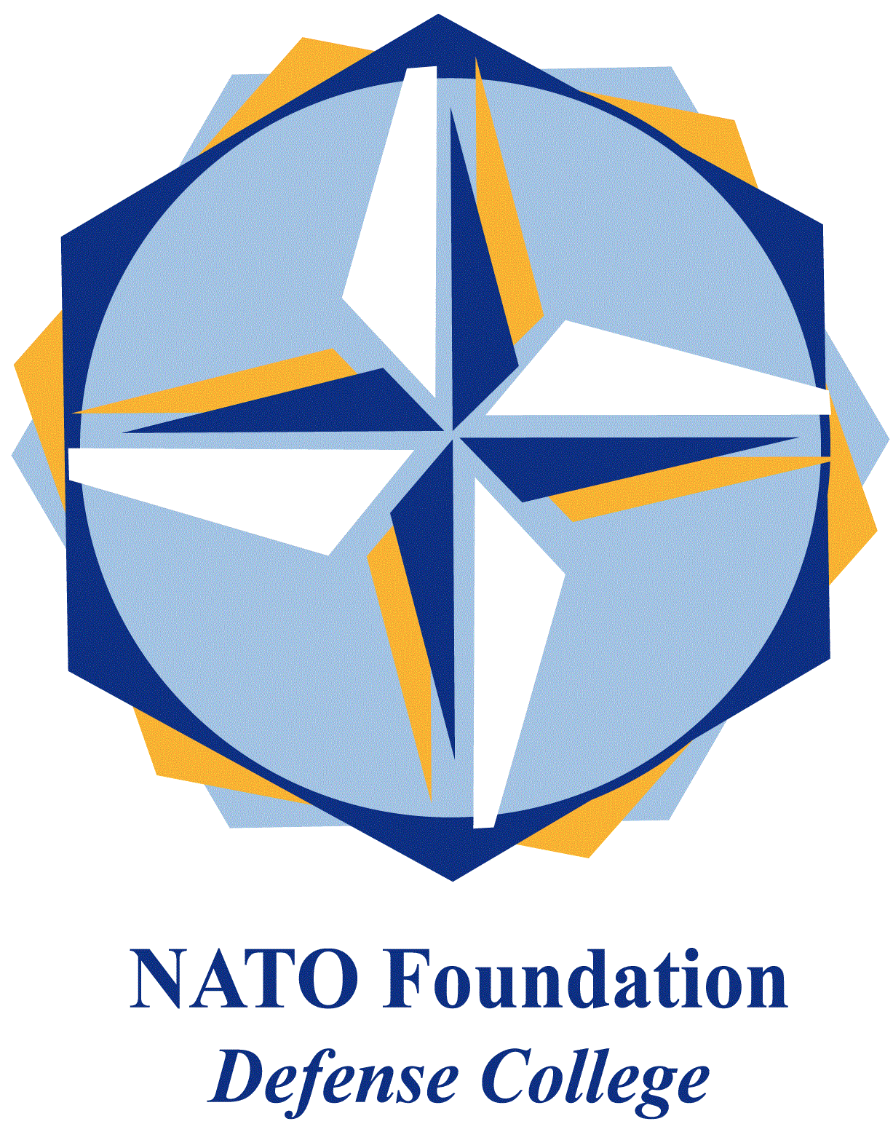
NATO DEFENSE COLLEGE FOUNDATION
STRATEGIC TRENDS
July 2015
LEVANT
Turkey’s involvement in Syria, more questions than answers
The most noteworthy event for the Levant in July deals with a change in Turkey’s foreign policy and its positioning in the regional strategic chessboard. On July 20th a suicide attack took place in Suruç in the Şanlıurfa province, killing 32 people and injuring more than 100. The attacker is believed to be affiliated to Daesh. If confirmed, this would be the first major attack carried on by Daesh in the Turkish territory. The Turkish government has declared to hold Daesh responsible for the attack and to be ready to retaliate.
A week later, Turkish officials met leaders of rebel brigades in Aleppo to discuss a new effort to eliminate Daesh from the stretch of land it controls along the Turkish border. Ankara pressed the rebels to organize their ranks in preparation for the upcoming assault and promised to take unprecedented steps, including providing air support to sustain the offensive. A day after a similar meeting took place with military commanders of the foreign powers that are supporting the armed opposition, including the United States.
The strategy would be to establish a joint military operations room between rebel brigades to coordinate their positions along the Syrian-Turkish front lines, share intelligence, and provide a conduit to their regional allies to request airstrikes that would enable their assaults on jihadi positions. However, as an US official declared, the interlocutors among the anti-Assad front will be the same engaged in the past years, which then raises the question of how they could be convinced to bridge their long-standing, deep-seated differences now.
Finally, this strategy comes after Turkey finally allowing US and allied warplanes to depart from Turkish air bases in the south of the country to conduct airstrikes against Daesh. However this renewed agreement rests upon a quite significant difference in Ankara’s and Washington’s strategic objectives. In particular, the role of Kurds in the future geopolitics of the Levant is a major reason for disagreement.
In these past months the United States has coordinated closely with the Kurds, essentially transforming its air campaign in Syria into an effort to facilitate the Kurdish advance: for example, the US military supported Kobane in a way which cannot be compared to their support for Aleppo. On the other hand, for Ankara, the Kurds are mostly a threat. The dominant Kurdish party in Syria, the Democratic Union Party (PYD), is an affiliate of the Kurdistan Workers’ Party (PKK), the Turkish insurgent group traditionally engaged against the Turkish government. This would explain why Kurdish parties have even accused the Turkish military of shelling a Kurdish-held town both along the Syrian-Turkish border and in northern Iraq with the excuse of bombing Daesh.
To sum up, Turkey’s new role in the Syrian conflict, raises more questions than it provides answers. For example, how does President Erdoğan’s strategy of self-interest bode in the perspective of putting an end to the Syrian conflict? And still, does Turkey only want to mitigate Washington’s current dependence on the Kurdish PYD, or also presenting (or-representing) itself as the most viable partner for Washington? And if so, is Washington ready to trust Erdoğan again? The answers to these questions can undoubtedly imprint new decisive shifts to the strategic outlook of the Levant.

